AZURE ASSIGNMENT

Step – 1: Virtual Network Creation after subscribing

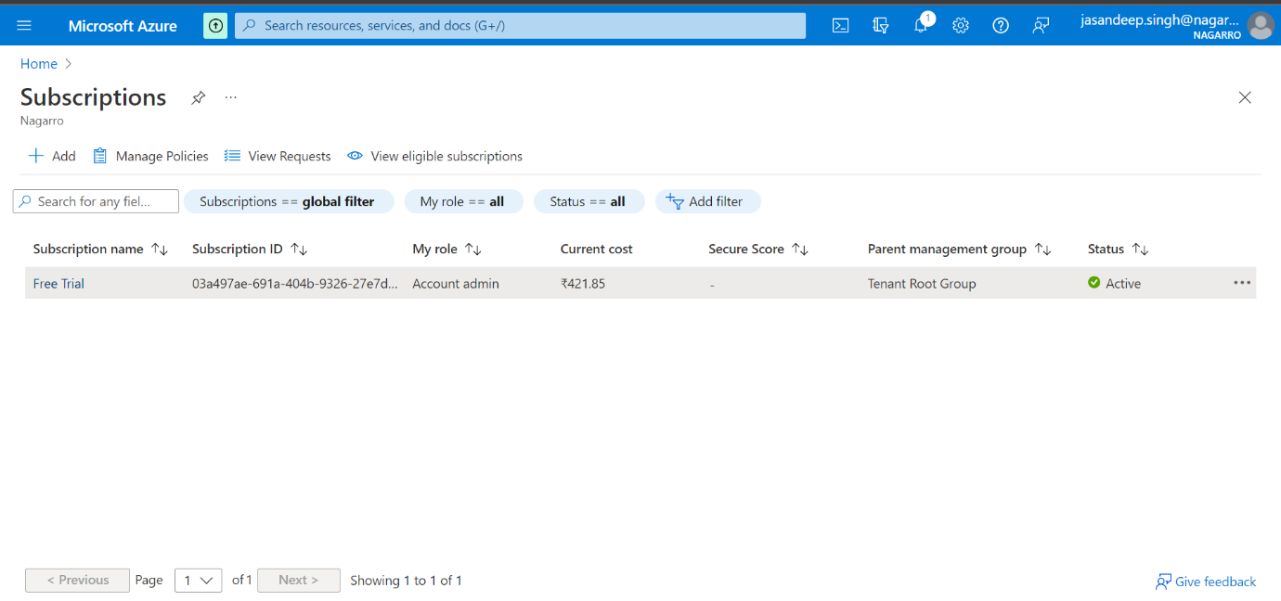

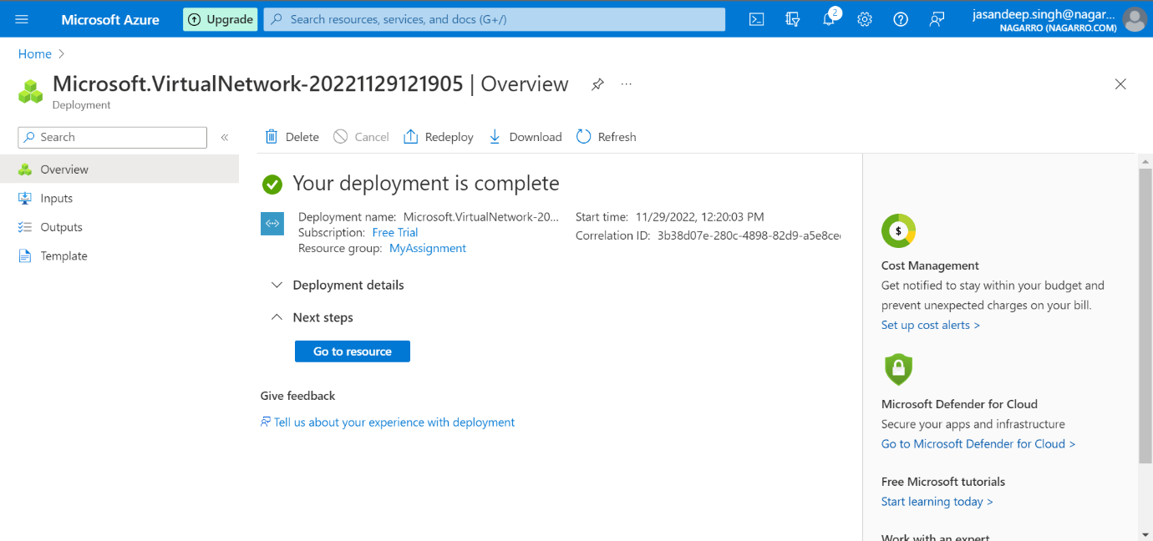

Step – 2: Subnet Creation

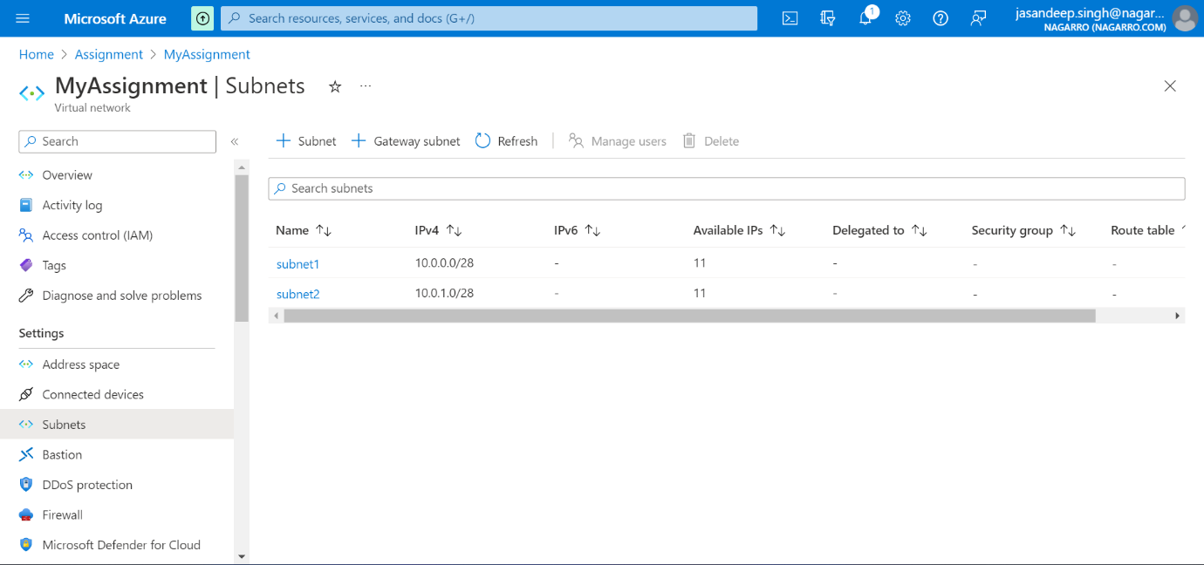

Step – 3: Virtual machine creation inside subnet 1

Step – 4: Web App service creation and deployment

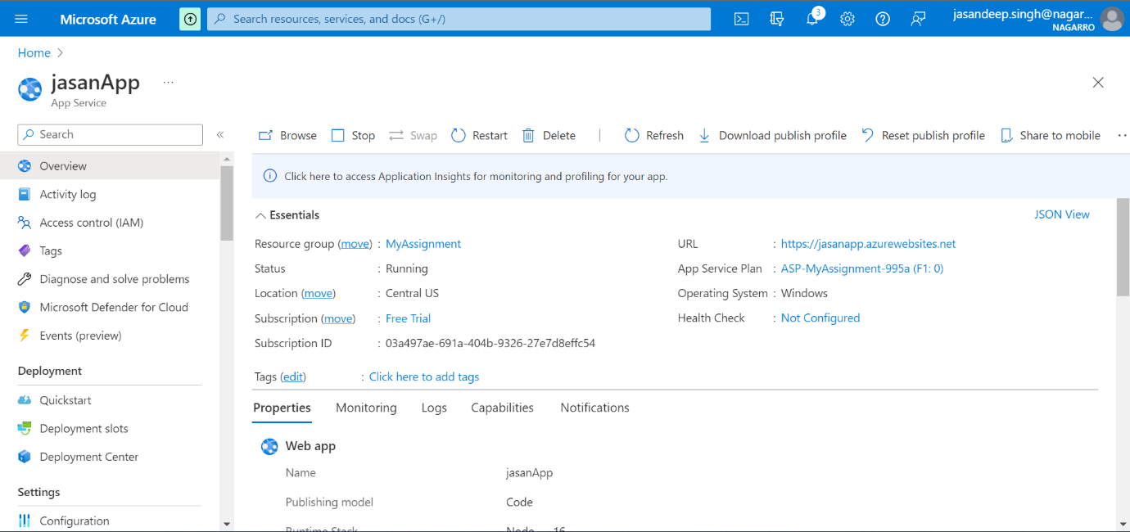

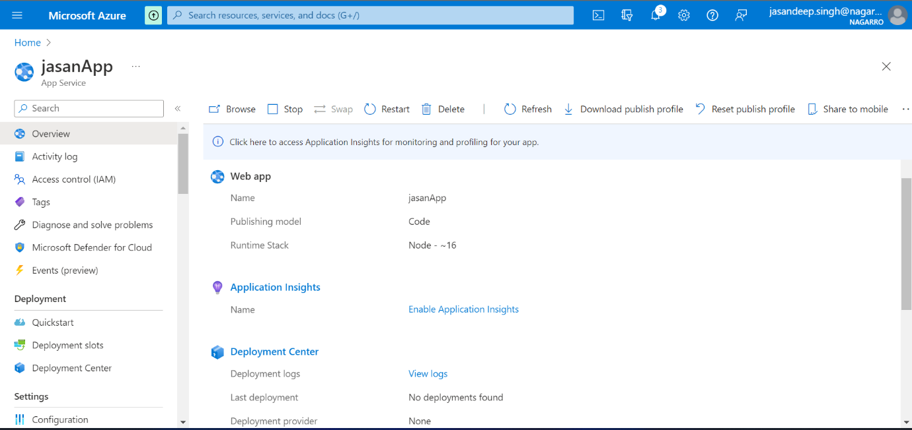

Step – 5: Creating AKS cluster and deployment

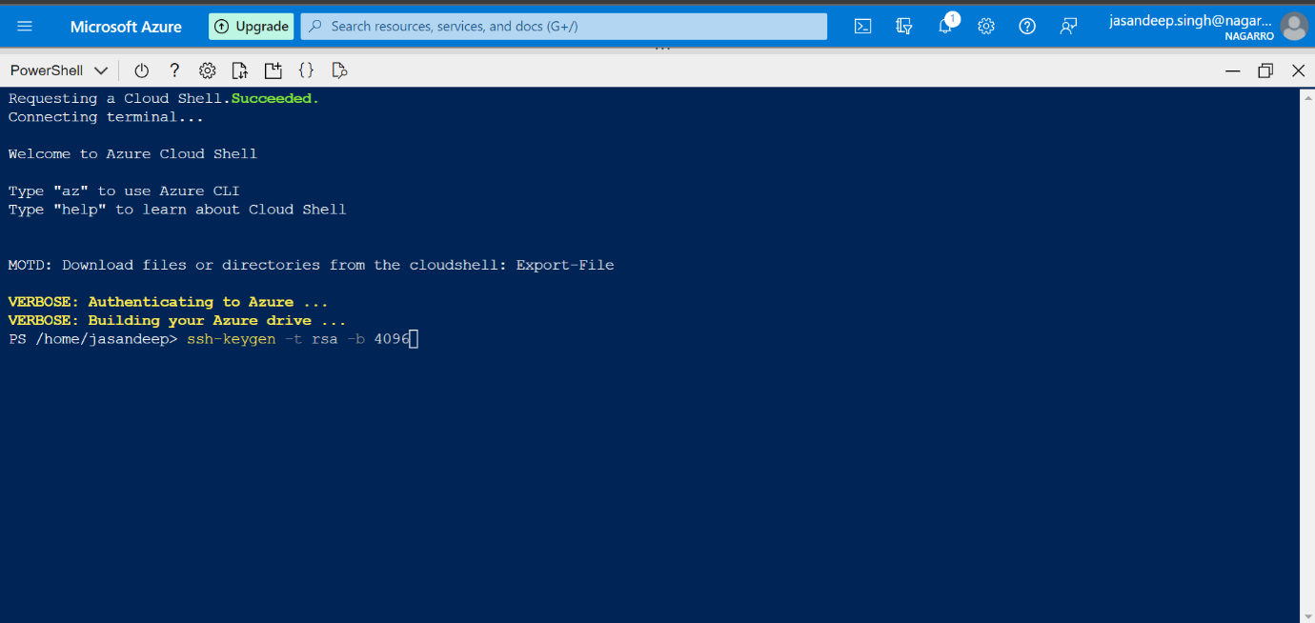

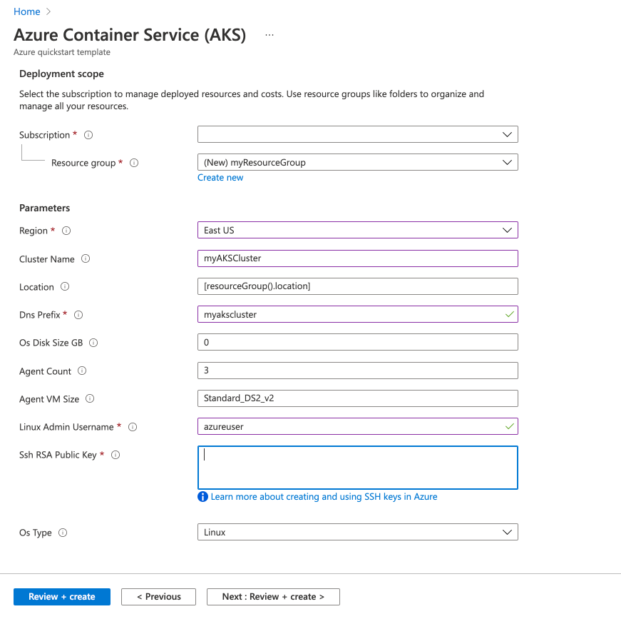

Step – 6: Creating an Azure function that should trigger as soon as we upload a file in the blob storage.

